Presentation Skills Self-Assessment
put a  beside the things that you are good at
put an  beside the skills you’d like to improve

 | Clear idea of how to plan a presentation
______ | Develop professional engaging slides
______ | Managing nervousness beforehand
______ | Building rapport with the audience
______ | Dynamic opening of speech or presentation that captures audience attention
______ | Well-paced presentation (e.g. pace of speech, amount of information)
______ | Well-modulated voice
______ | Practice presentation beforehand
 | Present with spontaneity rather than read or memorized
 | Mastering use of technology during presentation
 | Dealing with Questions

Other areas you would you like to improve?

____________________________

____________________________

____________________________

Presentation Interview
Interview your partner and get answers to the following questions in 2 minutes.
Take brief notes and then report back.

- What is your experience of giving presentations?

- What do you like about it?

- What do you dislike about it?

- Will you need to present in the future?

Giving Presentations
Overview: Presenting your research at a conference for the first time may be a daunting task. This short guide should help you to plan, prepare, practice and deliver your presentation.
Resources Required: MS PowerPoint, Mac Keypoint

Planning
What? Why? Where?
First of all, answer the following questions?
Who is your audience?
Why are they there?
How long will it be?
Where will it take place?
Simplicity
Simplicity is the key to a good presentation. Here are a few tips:
Focus on the most important points
Have one key message around which you base your presentation
Write down 3 things that you want the audience to take away with them
Develop an outline
Don't open PowerPoint
Work in a form (e.g. pen & paper) that allows you be creative
Establish the key points that you will focus on
Work out your key message
Develop the logical flow of your presentation
Structure
Good presentations have an engaging beginning, a more detailed middle and a final summary ending.

Intro: This includes a thesis statement or overview. Try to get the attention of the audience with an interesting fact, a question, something humorous or an eye-catching visual aid. The first few minutes are critical!

Middle: This part of your talk covers the main points (remember the Kiss principle, “Keep It Simple Stupid”). This is where you develop your position. Try to link your ideas coherently so the presentation flows and makes sense.

End: This is where you briefly sum up your talk by restating the main points and presenting your conclusions. Make sure to thank people and ask for comments/questions.

More?
Always check the conference guidelines for specific details re. time, resources available etc.

Preparing
Preparing your presentation is straightforward if you've planned your talk well and have a logical well-developed outline and structure. Nowadays, PowerPoint dominates presentations. Remember it is only a small element of your presentation. The following tips should help you in your preparation.
3 friends
Prepare 3 documents for your presentation:
1) Your notes which no else sees
2) Handouts with more detailed information & references
3) Visual aids (usually PowerPoint) that support your talk and help engage the audience.

PowerPoint Tips
Keep text to a minimum - avoid full sentences, keep level of bullets to a minimum. Use colour to focus people on the most important details. Use images to support your content.

Accessibility
Prepare a presentation that welcomes everyone. Below are some guidelines:
  - Minimum font size of 18 (ideally 30)
  - Easily read fonts (sans serif) like Arial, Helvetica, Tahoma.
  - Limit the amount of onscreen information
  - Avoid blocks of text
  - Use ‘bold’ to highlight points rather than underlining
  - Use both uppercase and lowercase letters (avoid ALL UPPERCASE)
  - Keep backgrounds simple, avoid patterns
  - Dark text on light background for bright rooms
  - Light text on dark background for dark rooms.

More?
  - Images for your Presentation: http://sxc.hu/ (free) www.istockphoto.com (commercial)
  - PowerPoint Themes: http://www.presentationmagazine.com/free_powerpoint_template.htm (free)
  - http://www.presentationload.com (commercial)

Practicing
Most people never practice delivering their presentation. It is essential. It gives you a chance to correct things you don’t like and it gives you confidence.
Preparation and practice are the best medicine for nerves:
- Become familiar with the venue - practice there if possible.
- Try imagining the room and giving the presentation in a successful way.
- Anticipate what might go wrong and prepare ahead, i.e. a glass of water in case your mouth goes dry.
- Take a deep breath, inhaling through the nose and exhaling through your mouth to relieve tension – no one can see you do it!
- If you need to use a script, make sure that it’s written in casual spoken language. Even the best speakers often write down the wording of key phrases.
- Work out what you are going to do with your body: are you going to stand behind the podium? If so, how can you ensure you connect with the audience? If you are going to stand in front of the audience, what are you going to do with your hands?
- Have a bottle of water – it will help you pause naturally, stop your voice from going dry and it also helps to relax you.
- Before your talk, build up your confidence and warm up your voice by asking questions in previous presentations or by talking to audience members as they come into the room.
- Finally, make sure you have some time before your talk to relax and take your mind off your presentation. If you’ve prepared your material and practiced your presentation, you’ll be fine!
Rehearse
In a place as similar to the real venue that you can find
Build up to your performance.
Only practice doing it right.
Cardinal sins
If you are presenting a conference paper DO NOT READ IT – have a hard copy as a handout
Do not turn your back on the audience
Do not read from your slides
More?
Try to get a friend to listen to your practice and ask them for honest feedback
More tips on practicing your speech:
http://sixminutes.dlugan.com/speech-preparation-8-practice-presentation/
Presenting on the Day
If you've followed the previous steps, then on the day you can focus on delivering your presentation in the most engaging way.
If possible check out the room to ensure everything works and you have an idea of the layout.
Try not to “read” your talk. Use cue cards to prompt your memory.
Use a conversational tone. Make sure you are speaking loud enough to be heard.
Try to be enthusiastic.
Make sure to pause between points, indicating to the audience a change and helps to slow down your pace.
Body Language
Body language has a significant impact on an audience’s impression.
maintain eye contact
face the audience
try smiling occasionally!

Relaxation Techniques
Breathing – Positive Thinking – Bottle of water

Final Check
Check room, time, equipment – get grounded
Check sound levels
Practice your timing
Check that your presentation works

Be enthusiastic and enjoy your presentation. If you don’t, no one else will.
More?
  - more delivery tips see here: http://www.garrreynolds.com/Presentation/delivery.html
Graphical Examples of bad and good powerpoint

Box 3: Presentations vs. Journals
 | Presentations | Journal Papers
Introduction | - 40% | - 5-10 %
Ideas | - Ideas 1 per 5 mins. | - No limit
Repetition | - Repetition desirable | - Undesirable
Length | - Length - available time | - Depends on journal
Visuals | - A lot of Visual material | - Only where relevant
Grammar | - 1st and 2nd person | - 1st sometimes, 2nd never
Tone | - Conversational | - Formal

The Good and The Bad Powerpoint

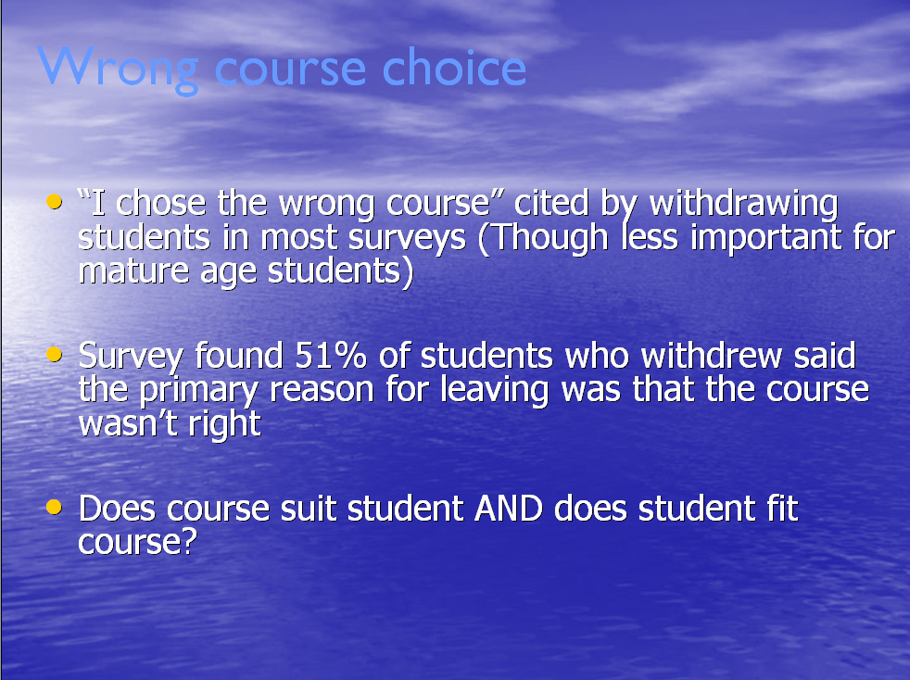

General Guidelines for Presenting

Garr Reynolds 10 tips to presenting

- Keep it simple

- Limit bullets & text

- Limit transitions and animations

- Use high-quality graphics
  - Avoid using PowerPoint Clip Art or other cartoonish line art.
  - Again, if it is included in the software, your audience has seen it a million times before.

- Have a visual theme but avoid Powerpoint templates

- Use appropriate charts
Always be asking yourself, "How much detail do I need?" Presenters are usually guilty of including too much data in their on-screen charts.

- Use colour well
Colour evokes feelings. Colour is emotional. The right colour can help persuade and motivate. Studies show that colour usage can increase interest and improve learning comprehension and retention.

- Choose your fonts well
Gill Sans as it is somewhere in between a serif and a sans-serif font and is professional yet friendly and "conversational."

- Use Audio & Video

- Spend time with the slide sorter

For more detail on these points visit this website:
http://www.garrreynolds.com/Presentation/index.html

10/20/30 Rule
Guy Kawaski’s 10/20/30 Rule of Powerpoint states that a presentation:

“should have ten slides, last no more than twenty minutes, and contain no font smaller than thirty points.”
10 | Ten is the optimal number of slides in a PowerPoint presentation because a normal human being cannot comprehend more than ten concepts in a meeting
20 | “You should give your ten slides in twenty minutes. Sure, you have an hour time slot, but you’re using a Windows laptop, so it will take forty minutes to make it work with the projector. Even if setup goes perfectly, people will arrive late and have to leave early. In a perfect world, you give your pitch in twenty minutes, and you have forty minutes left for discussion.”
30 | The reason people use a small font is twofold:  -> they don’t know their material well enough  -> they think that more text is more convincing.  Force yourself to use no font smaller than thirty points. It will make your presentations better because it requires you to find the most salient points and to know how to explain them well.

PowerPoint Accessibility

AHEAD guidelines 2008 http://www.ahead.ie

Minimum font size of 18 (ideally 30)

Try to use easily read fonts (sans serif) like Arial

Limit the amount of onscreen information

Avoid blocks of text

Use ‘bold’ to highlight points rather than underlining

Use bullet points rather than sentences

Use pictures or simple diagrams to illustrate points

Use double rather than single spacing

Use both uppercase and lowercase letters (avoid ALL UPPERCASE)

Use sufficient colours and brightness for better visibility

Keep backgrounds simple, avoid patterns

Have a theme: Maintain consistency of style and colour through presentation

